

**Semester One Examination 2018**

**Question/Answer Booklet**

**MATHEMATICS SPECIALIST**

**UNIT 3**

**Section Two:**

**Calculator-assumed**

Student Name: _____________________________________

Teacher’s Name: _____________________________________

**Time allowed for this section**

Reading time before commencing work: ten minutes

Working time for paper: one hundred minutes

**Material required/recommended for this section**

**To be provided by the supervisor**

This Question/Answer booklet

Formula Sheet (retained from Section One)

**To be provided by the candidate**

Standard items: pens(blue/black preferred), pencils(including coloured), sharpener, correction tape/fluid, erasers, ruler, highlighters

Special Items: drawing instruments, templates, notes on two unfolded sheets of A4 paper, and up to three calculators approved for use in the WACE examinations.

**Important note to candidates**

No other items may be taken into the examination room. It is **your** responsibility to ensure that you do not have any unauthorised notes or other items of a non-personal nature in the examination room. If you have any unauthorised material with you, hand it to the supervisor **before** reading any further.

**Structure of this paper**

|  |  |  |  |  |  |
| --- | --- | --- | --- | --- | --- |
|  | Number of questions available | Number of questions to be attempted | Suggested working time (minutes) | Marks available | Weighting |
| Section One  Calculator—free | 7 | 7 | 50 minutes | 50 | 35% |
| **Section Two**  **Calculator—assumed** | **11** | **11** | **100 minutes** | **100** | **65%** |
|  | | | | 150 | 100% |

**Instructions to candidates**

1. The rules for the conduct of Western Australian external examinations are detailed in the *Year 12 Information Handbook 2018.* Sitting this examination implies that you agree to abide by these rules.
2. Answer the questions according to the following instructions.

Section Two: Write answers in this Question/Answer Booklet. Answer **all** questions.

**Show all your working clearly.** Your working should be in sufficient detail to allow your

answers to be checked readily and for marks to be awarded for reasoning. Incorrect

answers given without supporting reasoning cannot be allocated any marks. For any

question or part question worth more than two marks, valid working or justification is required to receive full marks. If you repeat an answer to any question, ensure that you cancel the answer you do not wish to have marked.

It is recommended that you **do not use pencil**, except in diagrams.

1. You must be careful to confine your responses to the specific questions asked and to follow any instructions that are specific to a particular question.
2. Spare pages are included at the end of this booklet. They can be used for planning your responses and/or as additional space if required to continue an answer.

* Planning: If you use the spare pages for planning, indicate this clearly at the top of the page.
* Continuing an answer: If you need to use the space to continue an answer, indicate in the original answer space where the answer is continued, i.e. give the page number. Fill in the number of the question that you are continuing to answer at the top of the page.

1. The Formula Sheet is **not** handed in with your Question/Answer Booklet.

# Section Two: Calculator–assumed 100 marks

This section has **eleven (11)** questions. Attempt **all** questions.

Write your answers in the spaces provided.

Working time: 100 minutes

**Question 8 (4 marks)**

Let $\vec{OA}=-2i+j+k$, $\vec{OB}=2i+αj-k$ and $\vec{OC}=6i+3j+βk$ with $α, β ϵ R$.

Determine the value(s) of $α$ and $β$ so that A, B and C are collinear. (4 marks)

**Question 9 (15 marks)**

A remote controlled drone flies at a fixed altitude along a plane parallel to level ground, and it

traces an elliptical path given by the equation

$$r=10\sin\left(\frac{t}{8}\right)i-6\cos\left(\frac{t}{8}\right)j$$

where $\left|r\right|$ is in metres, $t$ in seconds, $i$ is a unit vector pointing East and $j$ is a unit vector pointing North.

(a) How long does the drone take to complete one full cycle? (2 marks)

(b) Write an expression for the velocity of the drone at any time $t$. (2 marks)

(c) Determine the speed of the drone as a function of $t$ and find where on its path it moves the fastest.

(5 marks)

**Question 9 – Continued**

(d) On the grid below, sketch the path traced by the drone, indicating its position, direction and velocity for when

(i) $t=0$. (3 marks)

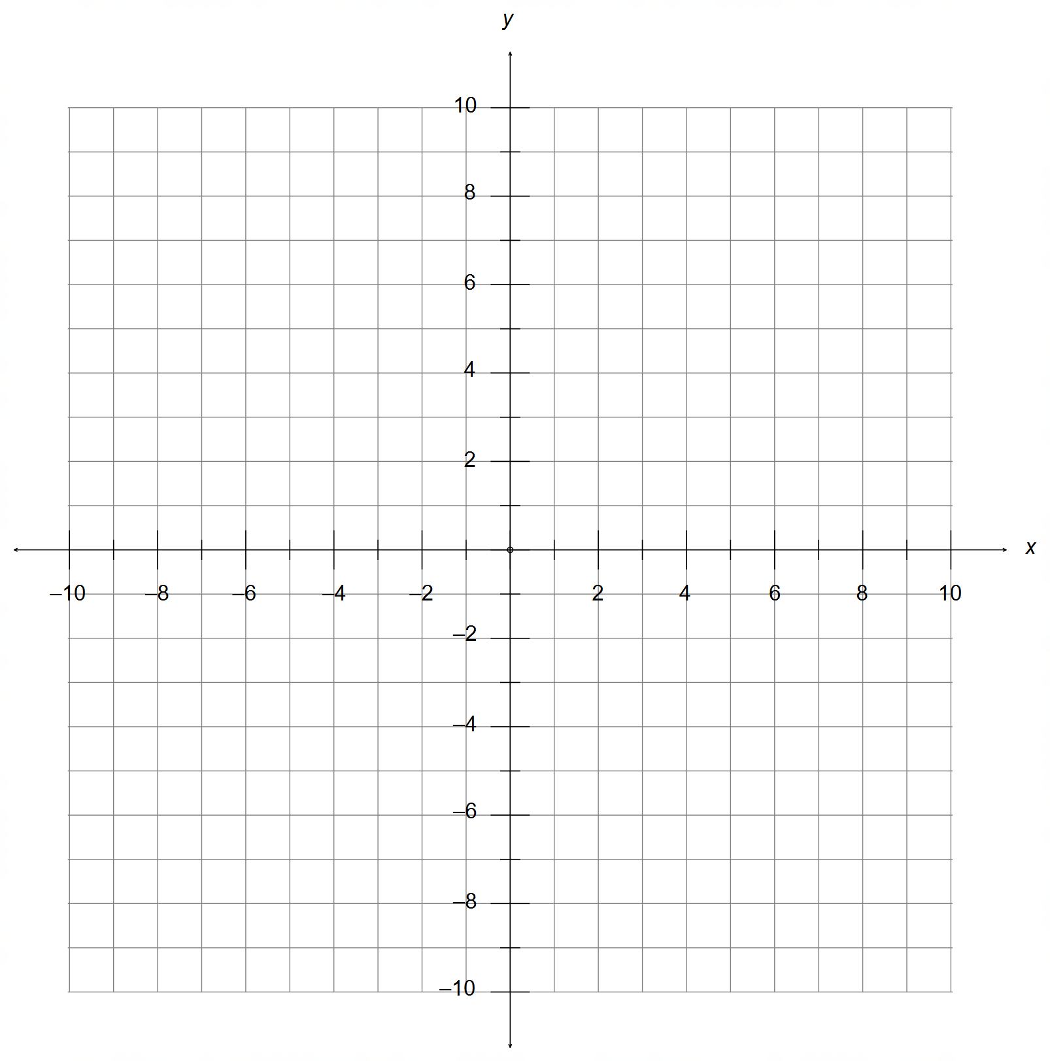 (ii) $t=6$. (3 marks)

**Question 10 (8 marks)**

The graph below shows the function $f\left(x\right)$ defined for $-4≤x≤5$.

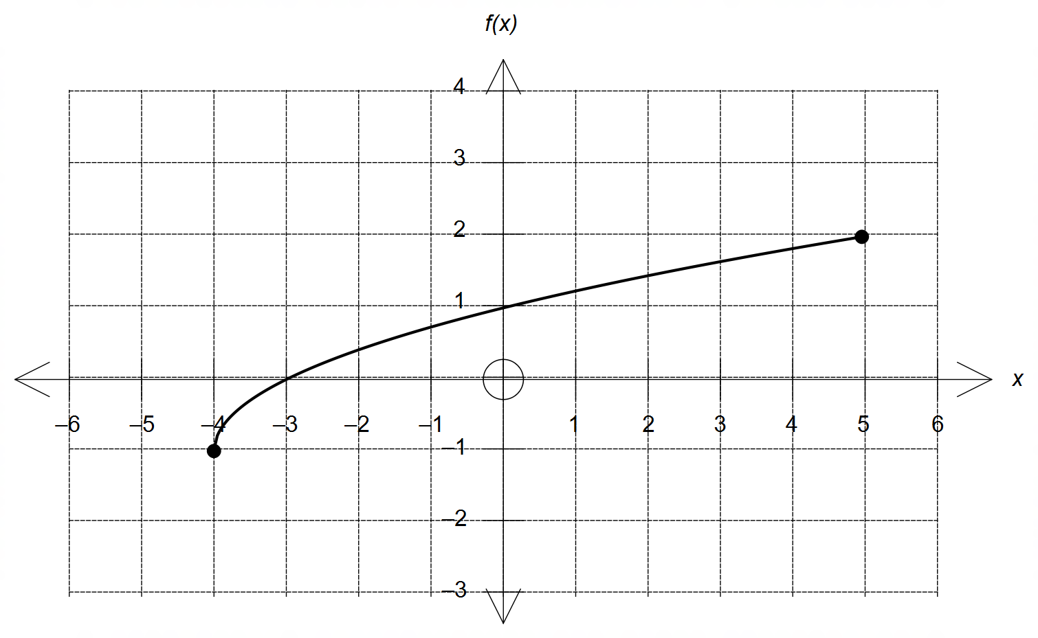

(a) Sketch the graph of $f\left(-\left|x\right|\right)$ on the grid provided below. (2 marks)

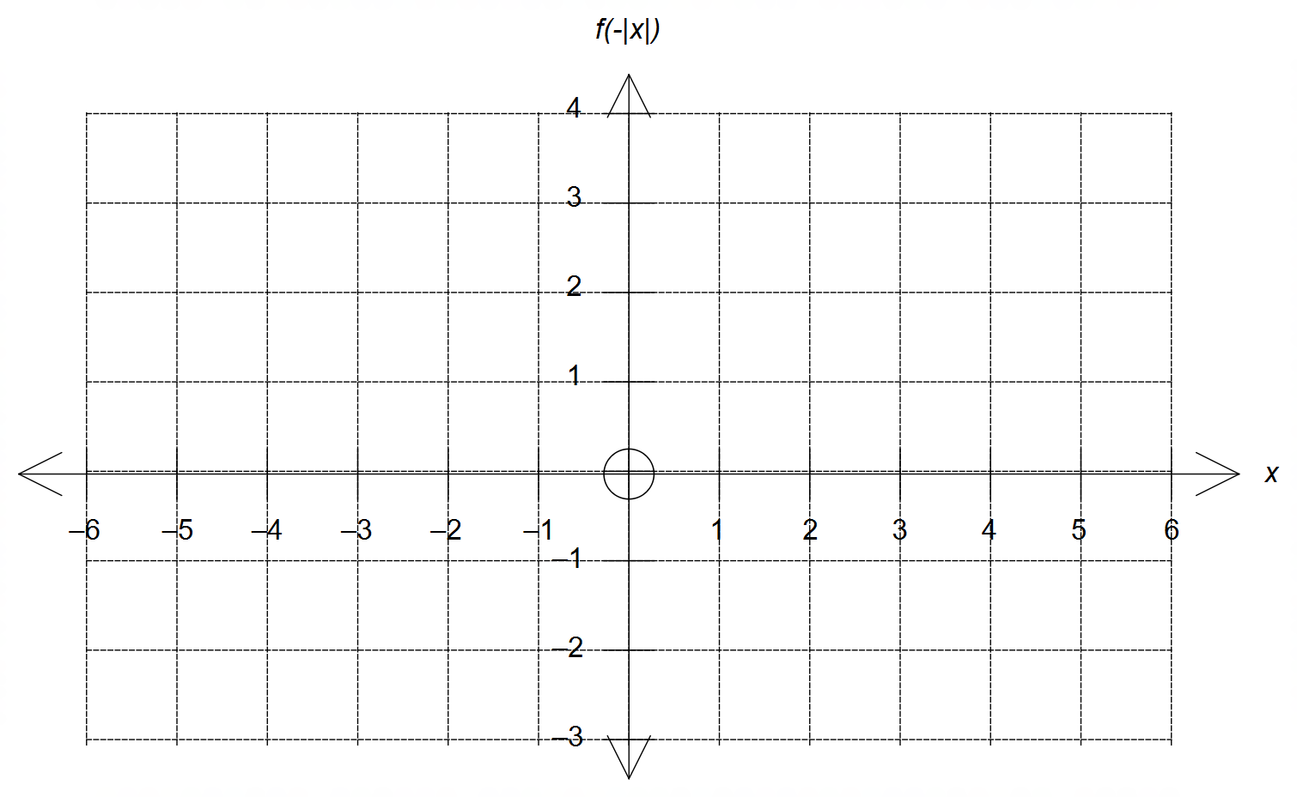

**Question 10 – Continued**

(b) Sketch the graph of $\frac{1}{f(x)}$ on the grid provided below, clearly indicating all of its graphical features. (4 marks)

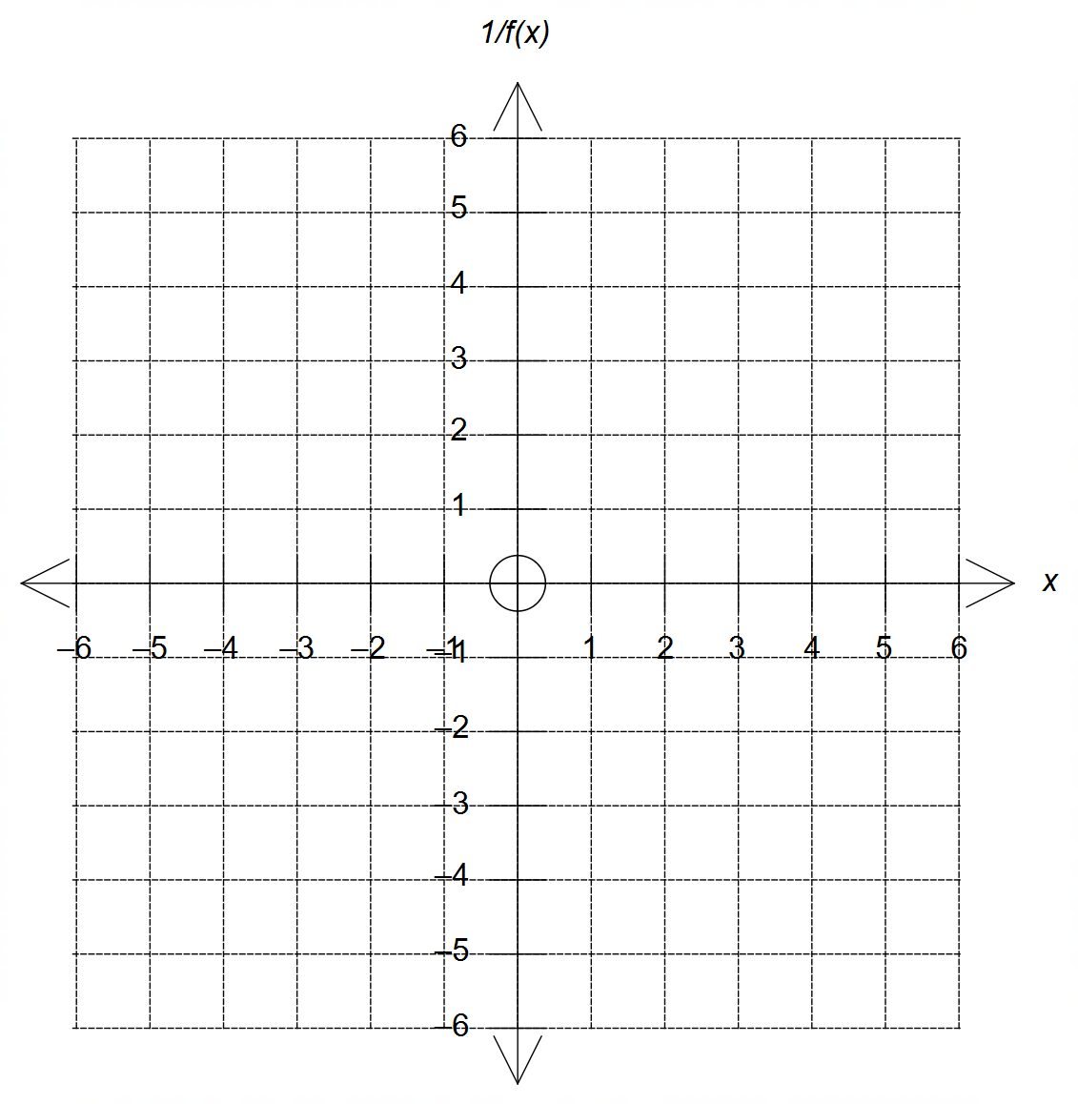

(c) Solve $f\left(\left|x\right|\right)-2=0$. (2 marks)

**Question 11 (10 marks)**

(a) State the conditions on the complex number $z$ that describe each of the loci given below.

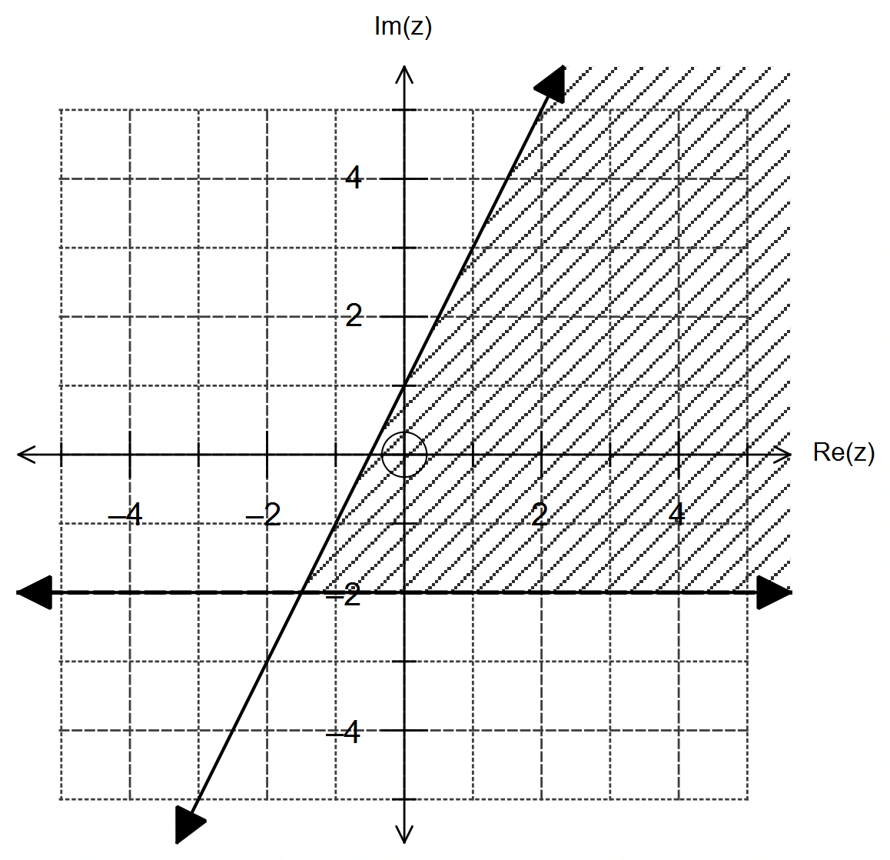

(i) (3 marks)

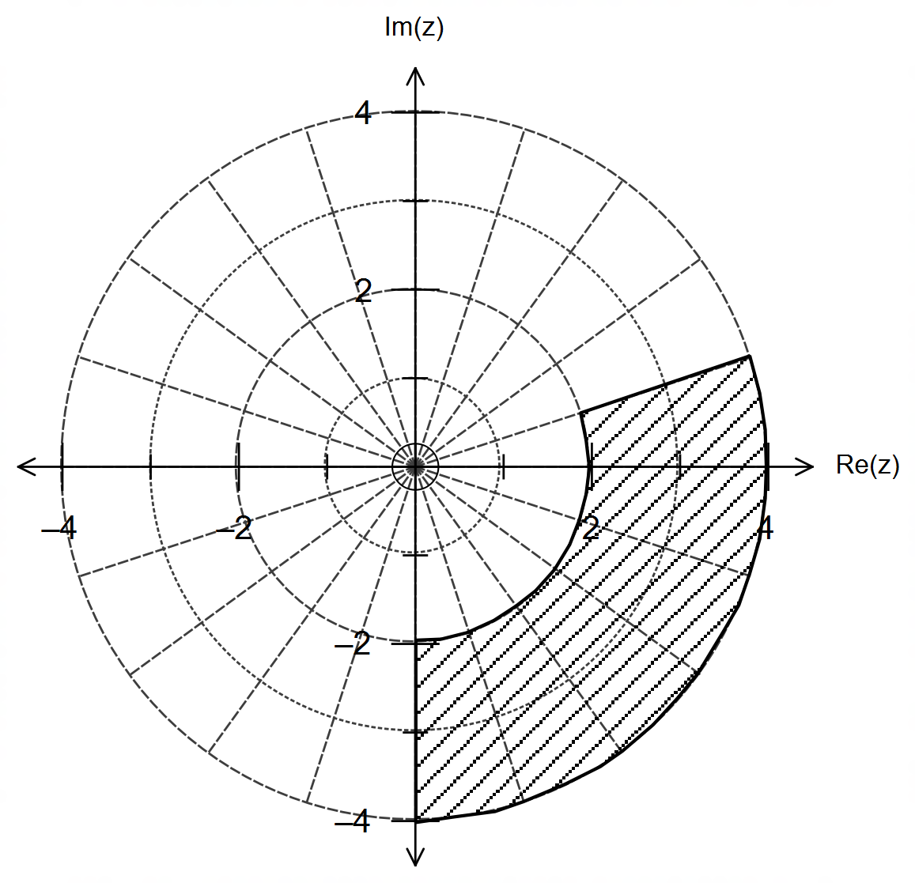

(ii) (3 marks)

**Question 11 – Continued**

(b) Sketch the following set of complex numbers $z$ in the Argand plane that satisfy the condition:

$$\frac{1}{z}-\frac{1}{\overline{z}}=i$$

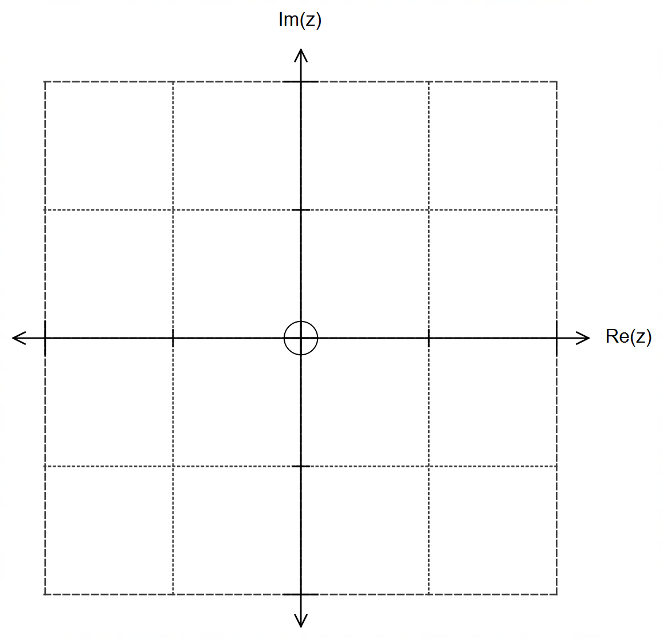

Justify your answer. (4 marks)

**Question 12 (11 marks)**

An aircraft-carrier is stationed at sea near a conflict zone.

At 1400 hr its underwater radars detect a hostile submarine at $-6i+12j-0.6k$ km relative to the aircraft-carrier stationed at O, and the submarine is moving with a constant velocity vector $v$ km/h.

(a) Computers calculate that the submarine will collide with the aircraft-carrier at O in 45 min if

it continues in the same direction and with the same speed.

Calculate the velocity vector $v$ of the submarine. (2 marks)

At 1420 hrs the aircraft-carrier begins to move with velocity $12i-12j$ km/h. At this instant the submarine is located at $-6i+9j-0.6k$ km and it is moving with velocity $6i-9j+0.6k$ km/h.

(b) Determine the distance between the two vessels at 1440 hrs.

(4 marks)

**Question 12 – Continued**

Torpedoes launched from the aircraft-carrier can travel under water at a speed of 500 km/h.

At 1500 hrs the aircraft-carrier is stationary and located at 8 $i-8j$ km from O.

At this instant the submarine is located $-2i+3j-0.2k$ km and it is still moving with a velocity vector of $6i-9j+0.6k$ km/h.

(c) At 1500 hrs a torpedo is launched from the aircraft-carrier. Determine the velocity vector of the torpedo and the time, to the nearest minute, that it takes for the torpedo to hit the submarine,

assuming that the torpedo goes at maximum speed.

(5 marks)

**Question 13 (10 marks)**

The graph below shows the function $f(x)=\left|ax^{2}+bx+c\right|$ where $a,b,c∈R$.

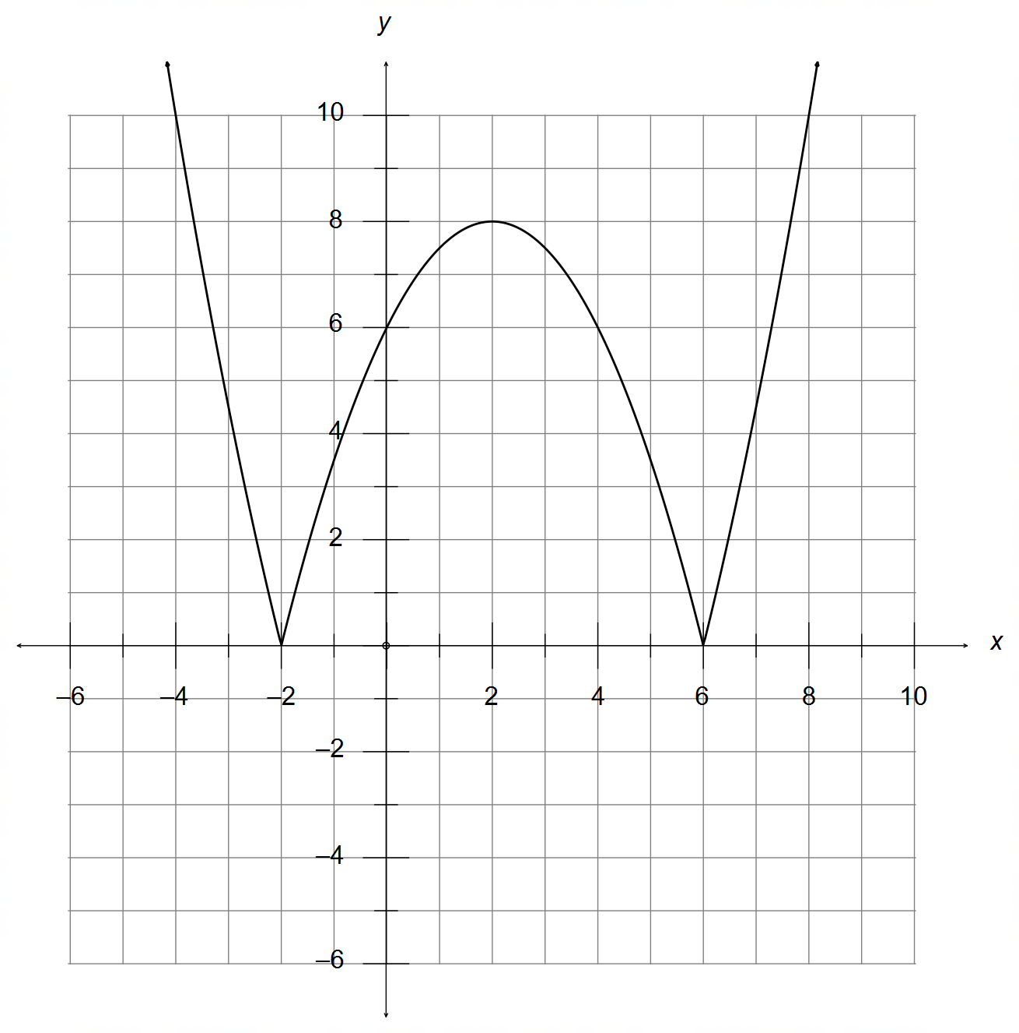

(a) Determine the value(s) of the constants $a, b$ and $c$. (3 marks)

**Question 13 – Continued**

The graph of $g(x)=\left|x+m\right|+n$ is added to the diagram, where $m,n∈R$.

(b) Add the graph of $g(x)$ on the diagram below for when $m=n=1$. (2 marks)



(c) State the condition(s) on $m$ and $n$ to ensure that the functions $f(x)$ and $g(x)$:

(i) intersect at least once. (3 marks)

(ii) do not intersect. (2 marks)

**Question 14 (10 marks)**

The sphere S is given by $x^{2}+y^{2}+z^{2}-2x-2y=0$.

(a) Complete the squares to determine the centre and radius of the sphere. (3 marks)

(b) The intersection of the sphere S and the plane $z=1$ follows the outline of a circle.

State the radius and centre of this circle. (2 marks)

**Question 14 – Continued**

The point P $\left(2, 1, 1\right)$ belongs to the sphere S.

(c) Determine the Cartesian equation of the line that passes through the centre of the

sphere and the point P. (3 marks)

(d) Determine the vector equation of the plane tangent to the sphere at the point P. (2 marks)

**Question 15 (11 marks)**

(a) Consider the set of complex numbers shown below that meet the condition

$$\left|z-2\sqrt{2}-2i\sqrt{2}\right|≤2$$

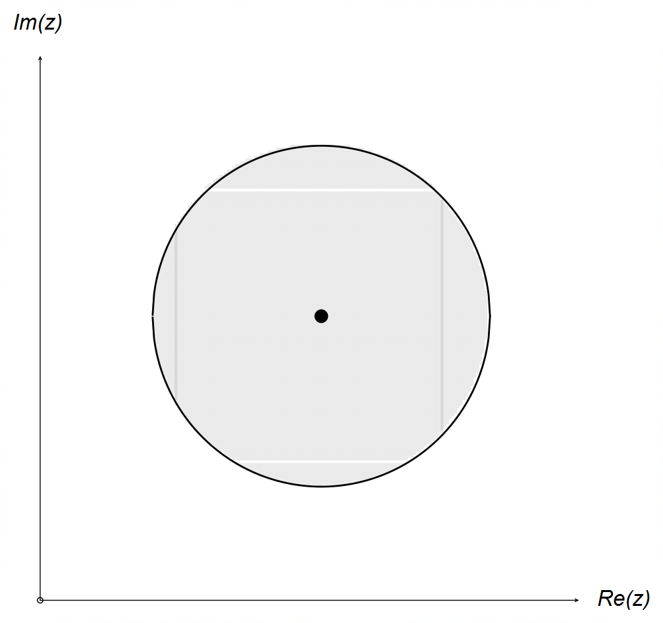

Determine, exactly,

(i) the maximum value of $\left|z\right|$. (2 marks)

(ii) the minimum value of $arg⁡(z)$. (3 marks)

**Question 15 – Continued**

(b) Consider the complex number $z^{n}=\cos\left(nθ\right)+i\sin\left(nθ\right)$ and its reciprocal

$z^{-n}=\cos\left(nθ\right)-i\sin\left(nθ\right)$, where $n∈N$.

(i) Obtain an expression for $\sin\left(nθ\right)$ and $\cos\left(nθ\right)$ in terms of $\left(z^{n}+z^{-n}\right)$ and/or $\left(z^{n}-z^{-n}\right)$.

(2 marks)

(ii) Using your answers in (i), expand ${\left(\frac{z + z^{-1}}{2}\right)}^{3}$ to show that $\cos^{3}{θ}=\frac{1}{4}\cos\left(3θ\right)+\frac{3}{4}\cos{θ}$.

(4 marks)

**Question 16 (10 marks)**

The function $f\left(x\right)=\frac{x + 2}{x - 1}$ is defined for its natural domain.

(a) Determine $f\left(f(x)\right)$. What conclusion can be made of $f(x)$ in relation to its inverse?

(3 marks)

(b) State the domain and range of $f\left(f(x)\right)$. (2 marks)

**Question 16 – Continued**

(c) The function $g\left(x\right)=\frac{x + 3}{x - 1}$ is its own inverse.

If the graph of $g(x)$ is reflected over the line $x+y=0$, does this new reflected function

continue to be its own inverse? Justify/explain your answer. (2 marks)

(d) Given that $f\left(h(x)\right)=1+\frac{1}{x}$, determine $h(x)$. (3 marks)

**Question 17 (6 marks)**

Consider the complex polynomial $P\left(z\right)=z^{8n}-z^{4n}+1$, where $n∈N$.

The complex number $w$ is a root of $P(z)$, i.e. $P\left(w\right)=0$.

Show that $\frac{1}{w}$ and $iw$ are also a roots of $P(z)$. (6 marks)

**Question 18 (5 marks)**

A particle moves along a path described by the equation $r=2\cos{θ}i+\cos\left(2θ\right)j$, where $0≤θ≤2π$.

Determine the Cartesian equation of the path described by the particle, and its respective

domain and range. Show working for full marks.

(5 marks)

**END OF QUESTIONS**

**Additional working space**

Question number(s): ……………………

**Additional working space**

Question number(s): ……………………

**Additional working space**

Question number(s): ……………………